Event Management System

Software Requirements Specification

Software Engineering Project

**Version 1.0**



**Group ID : 11**

**Group Members : 2016-CS-154, 2016-CS-161, 2016-CS-170, 2016-CS-177.**

**Supervisor Name :** Samyan Qayyum Wahla

**Department of Computer Science and Engineering**

**University of Engineering and Technology**

**Lahore**

* **Table of Contents:**

1. **Introduction……………………………………………………..**
   1. Purpose and scope……………..........................................
   2. Product Overview………………………………………..
2. **Project Management Plan………………………………**

2.1 SDLC Used……………………………………………

2.2 Commitment to the SDLC……………………………

2.3. Project Plan (same plan as provided in SRS)……………………………………….

2.4. Deviation from Project Plan…………………………………………………………..

2.5. Hardware and Software Resource Requirements…………………………………

2.6. Impact of the project on individuals and organizations……………………………..

2.7. Team Coordination…………………………………………………………….

**3. Requirement Specifications**

3.1. Stakeholders for the system……………………………………………………

3.2. Actors for the system …………………………………………………………..

3.3. Use case model (Diagram Required) ……………………………………………..

3.4. Textual Description for each use case (you can copy it from SRS) ………………..

3.5. Non-functional requirements

**4. Design**

4.1. GUI (Graphical User Interface) …………………………………………..

4.2. Deviation from proposed GUI ……………………………………………………

4.3. Static model – class diagrams ……………………………………………………..

4.4. Database Diagram …………………………………………………………………..

**5. Testing of Project**

5.1. Test Plan of the your system……………………………………………………….

**6. Deployment**

6.1. Link to the git repository……………………………………………………….

6.2. Deployment Plan of the your system……………………………………………….

1. **Introduction**

Event Management system is turning ideas into actions. From concept to completion it will provide all facilities required in managing event of societies of UET.

* 1. ***Purpose and Scope:***

Purpose of this project is to manage events of different Societies of UET. This project will be used by societies of UET so it has wide scope. They may organize gatherings,

discussion of important issues, review progress and planning of upcoming activities.

* 1. **Product Overview:**

This app contains the record of upcoming & pending events of registered societies. There are three stakeholders in this system: Admin, President, Volunteer.

**Capabilities and Scenarios:**

This app has specific tasks. Admin can register the users and can handle all the functions in the system. If app is provided to President, he/she will book and cancel the event, register the new society, and can approve request from the volunteers. If app is provided to Volunteers, he/she will make profiles and also edit it. Volunteers can view event gallery, can give feedback and also view feedback of others.

1. **Project management Plan**
   1. **SDLC Used:**

**Agile development methodology**

Agile software development are typically used to define requirements and iteration in a short period of time. It is basically an incremental model in which it’s easier to change the process to reflect changing customer requirements.

* 1. **Commitment to the SDLC**

Yes, we are committed to Agile methodology, we have followed it as we discussed it after every task and discussed errors and made changes according to requirements.

In event management system we have used Agile Methodology according to which our system is based on parts which are divided into sub parts.

**2.2.1 Project Identification and Selection**: In this part we aim to develop an event management system in which societies of Uet will book events, cancel events and manage event according to requirement.

**2.2.2**. **Project Initiation and Planning**: Before starting this project we have to gather requirements of users and prepare the scope and objectives, cost, benefits and user interface design.

**2.2.3**. **Analyzing system needs**: we have to study and identify problems of existing system also develop ER Diagram and Data flow diagram.

**2.2.4**. **Designing of proposed system:** we will convert ER diagram into database model.

**2.2.5. Development of the proposed system:** In this phase we are going to change design of proposed system into computer software by using ASP.net and SQL Server.

* 1. **Project Plan**

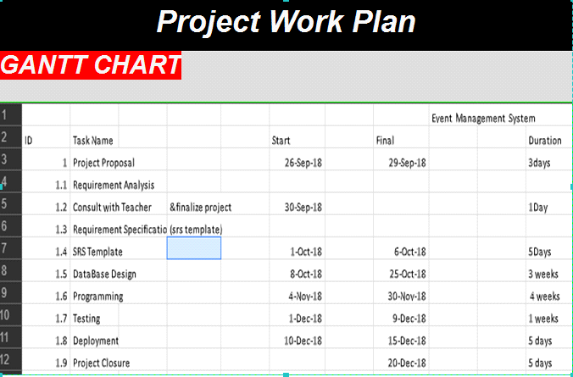

|  |  |  |  |  |  |
| --- | --- | --- | --- | --- | --- |
| ***Tasks*** | ***Name*** | ***Status*** | ***Type*** | ***Estimated***  ***Time*** | ***Actual***  ***Time*** |
| *Layout Index* | Umayya | Completed | Design Phase |  |  |
| Signup &login | Hira | Completed | Design Phase |  |  |
| Book&cancel Event | Ayesha | Completed | Design Phase |  |  |
| Register Societies | Mehreen | Completed | Design Phase |  |  |

|  |  |  |  |  |  |
| --- | --- | --- | --- | --- | --- |
| ***Tasks*** | ***Name*** | ***Status*** | ***Type*** | ***Estimated***  ***Time*** | ***Actual***  ***Time*** |
| ***Signup & login*** | ***Hira*** | ***Completed*** | ***Coding*** |  |  |
| ***Book&Cancel Event*** | ***Ayesha*** |  |  |  |  |
|  | ***Ummaya*** |  |  |  |  |
|  | ***Mehreen*** |  |  |  |  |

|  |  |  |  |  |  |
| --- | --- | --- | --- | --- | --- |
| ***Tasks*** | ***Name*** | ***Status*** | ***Type*** | ***Estimated***  ***Time*** | ***Actual***  ***Time*** |
|  | ***Umayya*** |  |  |  |  |
|  | ***Hira*** |  |  |  |  |
|  | ***Ayesha*** |  |  |  |  |
|  | ***Mehreen*** |  |  |  |  |

|  |  |  |  |  |  |
| --- | --- | --- | --- | --- | --- |
| ***Tasks*** | ***Name*** | ***Status*** | ***Type*** | ***Estimated***  ***Time*** | ***Actual***  ***Time*** |
|  | ***Umayya*** |  |  |  |  |
|  | ***Hira*** |  |  |  |  |
|  | ***Ayesha*** |  |  |  |  |
|  | ***Mehreen*** |  |  |  |  |

* 1. ***Deviation from Project Plan***

We deviate from our Project Plan in way that we faced so many error in database and other errors during coding.

* 1. ***Hardware and Software Resource Requirements***

**Hardware Requirement:**

This is a web application its hardware requirement includes any device that support the web application. It’s hardware requirements are

* 4GB RAM
* 80GB ROM
* Up to Window 7

**Software Requirement:**

For this project we will use ASP.Net using visual studio 2015, with C# language and SQL Server 2014 in SQL languages.

Internet will be required.

Up to Window 7.

* 1. ***Impact of the project on individuals and organizations***

Our event management system will have everlasting impacts by providing and delivering event solutions and services with highest standards of professionalism, creativity upholding at all times quality, integrity and innovation.

It will lead to error free, secure, reliable and fast management system that impact the society by creating innovative concepts to add extra flavour of joy to celebrations and meetings.

* 1. ***Team Coordination***

In our project the whole team has showed a great contribution & motivation towards the completion of project. Since we have used Agile Methodology so each member is trying hard towards each task.

# Requirement Specifications

* 1. **Stakeholders for the system**

In this system, stakeholders are

* Societies of UET
* Students of UET
* Developers
  1. **Actors for the system**

In this system, actors are

* Volunteer

Register itself in the system and login, can choose tasks for event, can give feedback.

* Admin

Can register users and will handle all the functions in the system.

* President

Register itself in the system and login, register the societies and book/cancel the events of societies.

* 1. **Use case model**

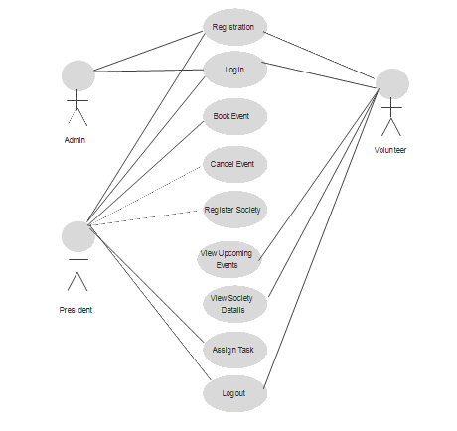

* 1. **Textual Description for each use case**

|  |  |
| --- | --- |
| **Use Case Title** | Member Sign up |
| **Use Case Id** | 1 |
| **Requirement Id** | 1 |
| **Description:** To enter into this site user has to register first. Requirements of registration are name, department, registration number, society name, address and phone number. | |
| **Preconditions:**   * User must fill all the questions of form in order to register in this application | |
| **Normal Flow** | |
| * User open the website. | |
| * System asks for necessary information. | |
| * Administrator provides all the required information to complete the operation. | |
| * To register yourself click Register button. | |
| * System after confirmation adds the new account. | |
| **Alternative Flow** | |
| . There is a problem in the data provided; some data needs to be corrected.   * Administrator checks the available information and corrects the error. | |
| **Post Conditions:**  After successfully registered in this application, user can easily login in this website. | |
| **Open issues:** | |
| **Authority:** Administrator | |

|  |  |
| --- | --- |
| **Use Case Title** | Member Login |
| **Use Case Id** | 2 |
| **Requirement Id** | 2 |
| **Description:** The system provide facility to any type of user(Volunteer, President) login into the system. | |
| **Preconditions:**   * Before login user must have an account. | |
| **Normal Flow** | |
| * User open the website. If he/she already have an account user can login. | |
| * Click on the Sign in tab located on the main screen. | |
| * Choose the Username and Password. | |
| * Click Login button. | |
| **Alternative Flow** | |
| The user is not registered and trying to be login   * System must generate the error message that user must create account before login. | |
| **Post Conditions:**   * user sign in to the account successfully. | |
| **Open issues:** | |
| **Authority:** Administrator | |

|  |  |
| --- | --- |
| **Use Case Title** | Book Event |
| **Use Case Id** | 3 |
| **Requirement Id** | 3 |
| **Description:** Societies can register their events and related information. | |
| **Preconditions:**   * Society's president must have an account. | |
| **Normal Flow** | |
| * Click on the Event details tab. | |
| * System required some necessary information about the event like date time place and event type. | |
| * Click on Book Event button. | |
| * System after confirmation adds the event of society. | |
|  | |
| **Alternative Flow** | |
| . Society is not registered on website and trying to book event of that society   * System will generate an error message that society's name is not registered on the website. | |
| **Post Conditions:**   * Societies book their event successfully. | |
| **Open issues:** | |
| **Authority:** Administrator | |

|  |  |
| --- | --- |
| **Use Case Title** | **Assign Task** |
| **Use Case Id** | 4 |
| **Requirement Id** | 4 |
| **Description:** This use case is about assigning task to the interested volunteers. President will inform volunteers that their request accepted or rejected via email. | |
| **Preconditions:**   * President and Volunteers must have an account. * Volunteer must send request to the president. | |
| **Normal Flow** | |
| * President can accept or reject the request from volunteers. | |
| * President will inform the volunteers that their request for task accepted or rejected. | |
| * President will send mail to the volunteers. | |
|  | |
| **Alternative Flow** | |
| Volunteer didn't send any request to president, and president assign task to that volunteer.   * Administrator checks the available information and corrects the error. | |
| **Post Conditions:**   * President assign task to the volunteers. | |
| **Open issues:** | |
| **Authority:** Administrator | |

|  |  |
| --- | --- |
| **Use Case Title** | **Cancel Event** |
| **Use Case Id** | 5 |
| **Requirement Id** | 3 |
| **Description:** This use case is about the society's president who wants to cancel the event from the website. | |
| **Preconditions:**   * Society must be registered. * Society's president must book the event of that society. | |
| **Normal Flow** | |
| * Only president has the authority of cancellation of an event. | |
| * President click the cancel event button. | |
| * President provide the required information about event which society wants to cancel. | |
| * System after confirmation cancel the event from the website. | |
|  | |
| **Alternative Flow** | |
| There is a problem in the data provided; if data doesn't same with the data which is entered on the book event time.   * Administrator checks the available information and corrects the error. | |
| **Post Conditions:**   * Event canceled successfully. | |
| **Open issues:** | |
| **Authority:** Administrator | |

|  |  |
| --- | --- |
| **Use Case Title** | **Give Feedback** |
| **Use Case Id** | 6 |
| **Requirement Id** | 5 |
| **Description:** User can give the feedback about the website. | |
| **Preconditions:**   * User must login to his/her account. | |
| **Normal Flow** | |
| * Open the website. There is a button Feedback on the main screen. | |
| * Click on this button. | |
| * Write your feedback here. | |
| * Submit the feedback on the website by clicking on the button | |
|  | |
| **Alternative Flow** | |
| . User is not login and trying to give feedback   * System will give message you should be login first. | |
| **Post Conditions:**   * Feedback is submitted successfully. | |
| **Open issues:** | |
| **Authority:** Administrator | |

**3.5.**  ***Non Functional Requirements:***

This application will always available online.

This application will save time and cost.

User can avail all facilities just a click away.

User’s data will be secured.

System will be portable and maintainable.

# ***4. Design***

**4.1. GUI (Graphical User Interface) design**

**4.2. Deviation from proposed GUI**

Our GUI deviated from that GUI which we proposed in SRS template because in this we download template related to our project, and made changes in our layout.

**4.3 Static model**

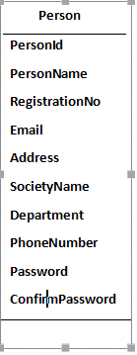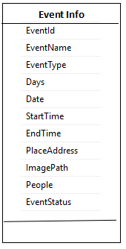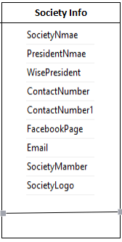

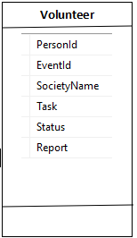 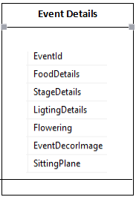

**4.4 Database Diagram**

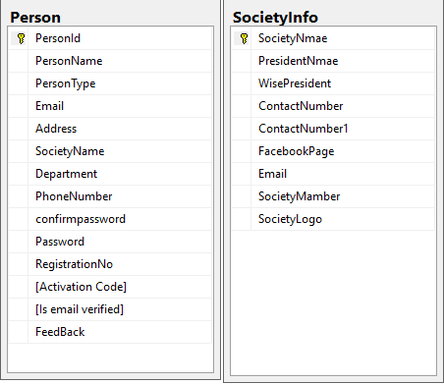

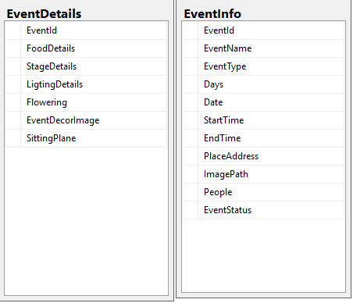

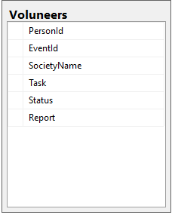

# 5. Testing of Project

**5.1 Test Plan of the your system**

Since we have used Agile Methodology so we tested each module in every iteration.

As testing is very important to debug errors so we have tried our level best to test each module.

**6. Deployment**

**6.1 Link to the git repository**

Here is the link of Git repository <https://github.com/umayya154/SE_lab_project.git>

**6.2. Deployment Plan of the your system**

We deployed our project on the laptop of our group members,we faced many network problems during deployment of project and we resolved them by searching the error online.